课题 | 7A Unit 3[来源:Zxxk.Com]  Welcome to our school![来源:学科网][来源:Zxxk.Com] | 总课时 | 8 | 第2课时
课题 | Reading1 |  |  | 备课时间 | 2015.9.23
 |  |  |  | 授课时间
教学目标 | - To learn how to introduce different teaching buildings to others。  - To know the main idea of the text.
教学重点 | To learn how to introduce different teaching buildings to others。
教学难点 | To learn how to introduce different teaching buildings to others。
教学过程 |  |  |  |  | 备注
Step1. Free talk
Ask: What day is it today ?
What subject do you like best ?
What’s the date of the open Day in Millie’s school?
Can Millie’s mother go to her school?
What time does the parents’ meeting begin ?
What else do parents’ meeting begin ?
Where does Millie meet her mother ?
What’s he/she like ?
How do you usually go to school ?
Step2. Presentation & Listening
1.Teacher says :Look at our school. Is it beautiful ?
Do you like your new school ?
Do you tell your parents about your new school ?
What can you see in the school ?....
Encourage Ss give their answers.
- Show a school picture and ask :
What can you see in the picture?
What’s in front of…?
Which room is our classroom in ?
How many floors are there in the building ?...

Step3. Practise
- Our school is a beautiful school. Today, some foreign visitors come to our school . Would you please look at the map and introduce our school to them ?
Eg 1. There are… buildings in our school.
2. There are…floors in the building.
3. …is on the ground floor.
4. The classroom is…
5….is in front of….
2. Encourage Ss to introduce the school with the simple languages
Step4 Presentation
- Introduce the text to the students, and present the new knowledge.
- Present different school buildings, let ss make dialogues
- Play the tape for the Ss, and do ExB1 and B2, judge True or False
Step5 Practise
- Read the text after the tape
- Practice in groups, give some questions
Where do you meet today ?
How does Millie’s school look?
How many classrooms are there in the classroom building?
What do you think of Millie’s classroom/
What else in her school? Where do you have the meeting?
Homework
- Read the text again and try to retell it .

- Finish the Workbook Ex2。(Reading 1)

教学随笔:

附件1：律师事务所反盗版维权声明
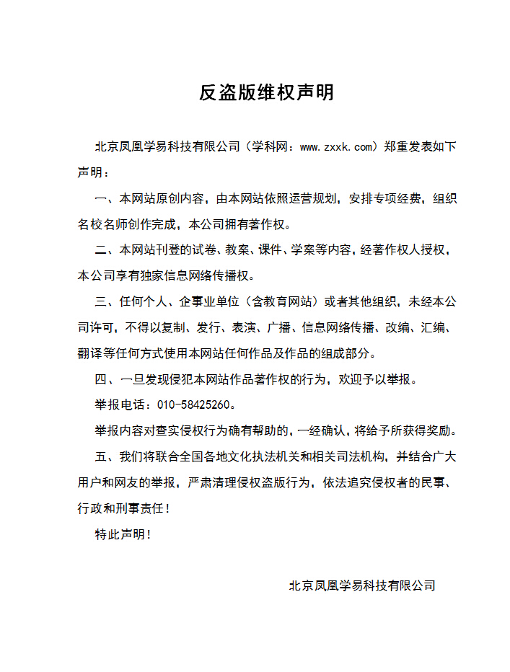
附件2：独家资源交换签约学校名录（放大查看）
学校名录参见：http://www.zxxk.com/wxt/list.aspx?ClassID=3060

